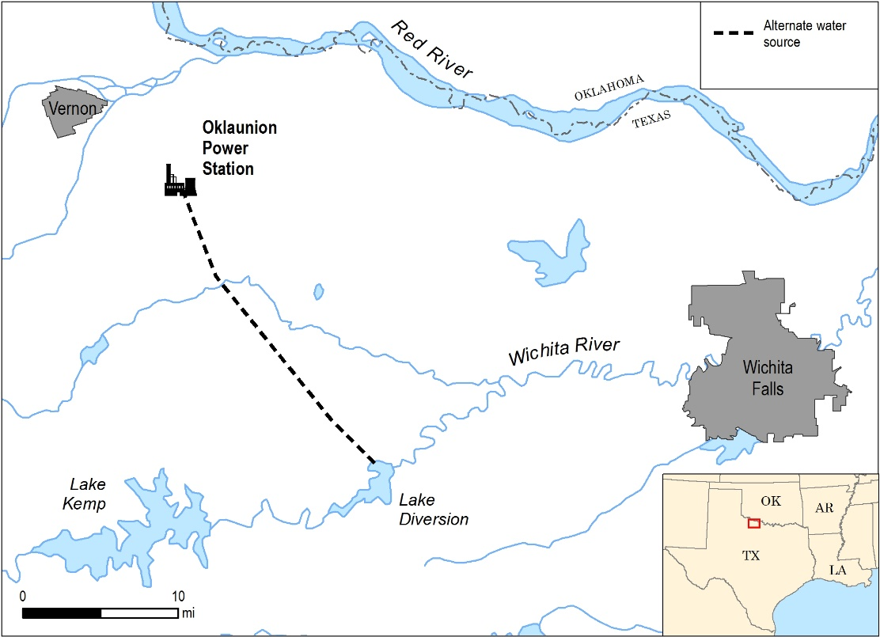
OVERVIEW
Oklaunion Power Plant (Oklaunion) is a 692 MW coal plant located near Vernon, Texas (population ~11,000). This zero discharge plant uses cooling towers and evaporation ponds, and began operation in 1986. On average, Vernon receives 28 inches of rain each year, and summer temperatures average almost 100 degrees F.
Oklaunion withdraws water from Lake Diversion, an impoundment with degraded water quality. Oklaunion has a contract for 20,000 acre-feet annually, with the water used for cooling.
BACKGROUND
Both Lake Diversion and Lake Kemp are impoundments of the Wichita River, built in the 1920s. Both lakes have high total dissolved solids (TDS) due to naturally-occurring salt seeps. In the mid-1970s, the Army Corps of Engineers installed a system upstream of Lake Kemp to divert the salt seeps into an artificial brine lake to reduce TDS. Water quality in both Lake Kemp and Lake Diversion improved as a result, although TDS remains high (~2,500-3,000 mg/l).
Lake Diversion has a total reservoir capacity of 35,324 acre-feet, and is owned by the Wichita County Water Improvement District No. 2 and the City of Wichita Falls. Under water right permit No. 5123, Lake Diversion is operated together with Lake Kemp as a system for municipal, industrial, mining, irrigation, flood control and recreational purposes with a water right priority of October 2, 1920. Lake Diversion is the water supply for the City of Wichita Falls’ Reverse Osmosis Water Treatment plant and the local irrigation district.
DRIVERS
 | Driver | Benefit | Challenge
Quantity | 
Quality
Reputation
Regulatory
Cost
The primary driver for using degraded water from Lake Diversion was the need for a reliable water source. The main factor in siting the Oklaunion plant at its current location was access to a main railroad line, along with the availability of a senior water right. Dry cooling was initially investigated for the plant, but was not economical. The Red River was also investigated as a freshwater source, but was deemed not viable for multiple reasons, including that it would have been a junior water right (subject to the 1978 Red River Compact between Texas, Oklahoma, Arkansas, and Louisiana) that might be unavailable during times of droughts and low flows. The configuration of the Red River floodplain near Oklaunion (75 ft. bluff drop off to the river) would have made construction challenging, and the reliability of the flow may have been affected because the Red River is braided and susceptible to changing its course during floods.
IMPLEMENTATION
Water is piped approximately 23 miles from Lake Diversion to Oklaunion. Because the influent has high TDS, the Oklaunion condenser was constructed with high nickel stainless steel, which is less susceptible to corrosion from chlorides. The contract allows Oklaunion to pump 20,000 acre-feet annually (~17.9 MGD), but the facility typically pumps approximately 6.9 MGD. The plant has a 1,172 acre-foot make-up water pond on-site that has about a 60 day design capacity at full load.
Water from the make-up pond is used directly in the cooling tower system. The cooling tower normally carries 5 to 6 cycles of concentration, cycling up to 25,000-30,000 mg/l TDS, before discharging to evaporation ponds. Water is also treated at Oklaunion to be used within the facility as boiler make-up and other process water.
There is zero liquid discharge from Oklaunion, which uses a series of 11 evaporation ponds to evaporate wastewater. Average gross evaporation in the region is ~65 inches/year, but evaporation can be even higher during drought years. For example, the adjusted gross evaporation rate at the Lake Kemp weather station was almost 97 inches in 2011.
BENEFITS & CHALLENGES
The primary benefit of using Lake Diversion for a water source is the availability of a reliable supply of water to the plant with a very senior water right. While evaporation rates can be extremely high at Lake Diversion, reservoirs do provide storage to help mitigate droughts that rivers and other water sources do not.
The degraded water from this source does not pose a challenge during normal conditions because the plant was designed to handle the high TDS. However, during the 2011-2015 drought, the worst on record, water quality and water quantity were both challenges to the plant. During the drought, TDS in Lake Diversion reached 10,000 mg/l. As a result, Oklaunion could only operate their cooling tower at 2 to 2.5 cycles of concentration. The increased blowdown rate at the lower cycles of concentration resulted in the evaporation ponds filling to near capacity. This latter challenge was addressed by construction of another evaporation pond.
Water quantity also became a challenge during the 2011-2015 drought when water levels in the Lake Kemp-Lake Diversion system dropped due to high evaporation rates and water use by farmers. In 2011, there were 92 days with 100°F or greater temperatures and no rain. A major portion of the water district’s water right is for irrigation purposes, so a large amount of water was used by farmers in an attempt to save their crops. The power plant faced the potential of not having access to water for the duration of the drought. The water district was forced to discontinue supplying irrigation water as the drought continued, but enough inflow was received to the system to maintain the water supply to Oklaunion and the City of Wichita Falls.
Other water sources were investigated during the 2011-2015 drought, either to supplement the current supplies or provide all of the power plant’s needs, but all were dismissed. Treated effluent from the City of Vernon, which is located 7.5 miles from Oklaunion, was dismissed because of insufficient quantity (20% of plant’s need), and because the use of this water would necessitate additional, costly infrastructure. Grey water from a manufacturing plant was dismissed as a potential source due to high organics, which would foul the cooling tower. Shallow alluvial groundwater was dismissed as a source due to reliability concerns and the potential for adverse impacts on local irrigation wells and subsequent negative public perception of the plant. Several deeper test wells were drilled in closer proximity to the plant, but no water bearing sands were encountered down to 800 feet. Finally, the surface water options of the Red River, Pease River, or Lake Kickapoo were investigated, but these options were dismissed due to high cost of capital investment, potential variability in supply throughout the year, and other uncertainties.
LESSONS LEARNED
Brackish surface water can be a reliable, cost-effective, long-term water source, even when the TDS approaches 10,000 mg/l.
Water users in this region of Texas continually manage their water use through cycles of drought. Oklaunion chose to use brackish water from Lake Diversion due to the reliability of the supply. The plant has been using brackish water for 30 years without any significant challenges, except during a record-breaking drought.
REFERENCES
Freese and Nichols, Inc. 2013. Oklaunion Power Station Water Supply Options: Technical Memorandum. April 17, 2013, Updated May 29, 2013. AEP13184.
Nexstar Broadcasting. 2017. Oklaunion Power Plant Looking at Alternative Water Sources. http://www.texomashomepage.com/news/local-news/oklaunion-power-plant-looking-at-alternative-water-sources/147822815 [Accessed 3/7/2017].
Personal communication, AEP staff, 2016. Tim Lohner and Greg Carter.
Texas Water Development Board. Lake Diversion (Red River Basin). URL: http://www.twdb.texas.gov/surfacewater/rivers/reservoirs/diversion/ [Accessed 1/19/2017].
Texas Water Development Board. Precipiation & Lake Evaporation. URL: http://www.twdb.texas.gov/surfacewater/conditions/evaporation/index.asp [Accessed 1/19/2017].
VERIFICATION
Water use information presented in this case study was provided through interviews with AEP staff in September 2016, who have reviewed this case study for accuracy.

